# TC-201 Lab QC Software Protocol for v2.0 software, by Joey

## Settings & Functions of Serial Port Utility (SPU) Software

1. Settings in SPU:
   1. Port Setting:
      1. (1) Port: “USB Serial Device COM#” – Select COM number port
      2. Baudrate: 9600 (Default)
      3. Data Bits: 8 (Default)
      4. Parity: None (Default)
      5. Stop Bits: 1 (Default)
      6. Flow Type: None (Default)
   2. (2) Receive/Send Settings: Select “Text”, and all other settings unchecked
      1. The “Hex” option will send unintelligible numbers

2

1

1. Functions:
   1. (3) The +/- icons adds/deletes windows for receiving data from multiple devices connected at once (make sure to select a different COM port for each window)
   2. (4) The “Start” function opens the ports and allow them to receive results
   3. (5) This “Quick Settings” function clears the results received in the windows
   4. (6) Click this icon if the settings window is not there Graphical user interface, application

      Description automatically generated

6

5

3

4

## Settings of QC Documents Software

1. Config Menu
   1. Update Ranges from Config File – Use after changing allowed ranges, or other variables, in the config.yaml file
   2. Show Allowed Ranges – Mostly for debug use; shows the lists of allowed ranges currently used by the program.

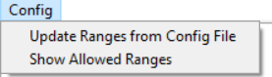

1. Config.yaml – The file that the program uses for allowed ranges and a few other variables
   1. Open with Notepad
   2. Allowed Ranges
      1. Strictly follow the existing format (i.e., quotes, parentheses, square brackets, and commas)
      2. Type in ALL possible results within a range, not just the start and end
      3. The ranges are listed in order from LEU to GLU

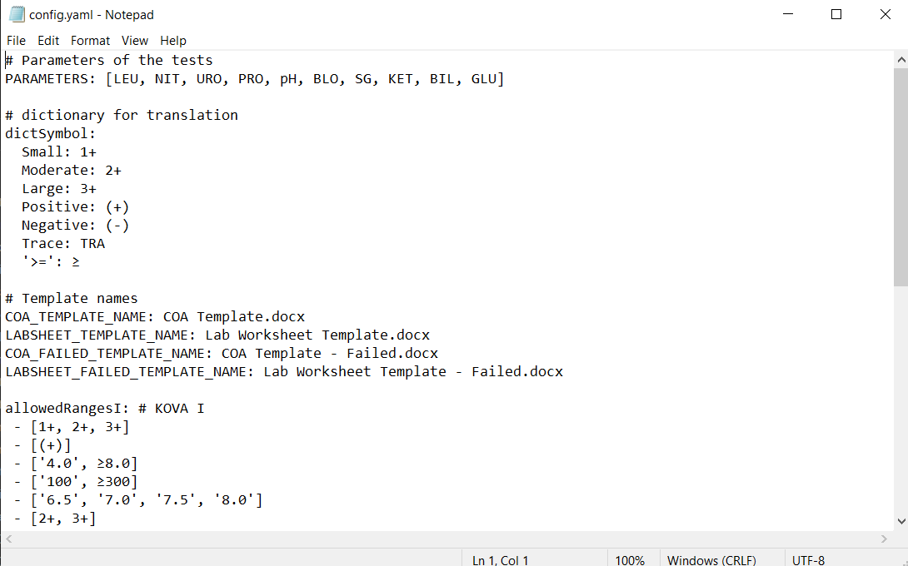

## Directions

1. Graphical user interface, text, application

   Description automatically generatedOpen Serial Port Utility (SPU) on Desktop and hit “Register Later” in the next window (it is an unnecessary feature).

1. Setting up the machines:
   1. Set up like when updating them, EXCEPT: You MUST plug the USB-C in AFTER the machine is turned on (else the machine would go into update mode and that will be no good)
2. After setting up the machines and the SPU (including selecting the right COM ports), hit the “Start” icon to open the ports.
   1. Make sure all open windows say “COM# OPENED SUCCESSFUL” on the bottom left and turns into “COM# OPENED”, like below:

* 1. If not, check if each window has their own COM port, if the cables are connected correctly, and if the machines turned on properly.

1. Go to the machines and click “Results” -> “Recall Results”, then “Send” to send the data to the computer.
   1. Note: The order you should send the results in is: KOVA I, II, III, I, II, III (subject to change)
   2. Make sure to send exactly six tests and in order; that will mess up the algorithm. You can change the results after you paste them into the text file, but be mindful not to mess up the format of results
2. This is what the SPU would look like after sending results:

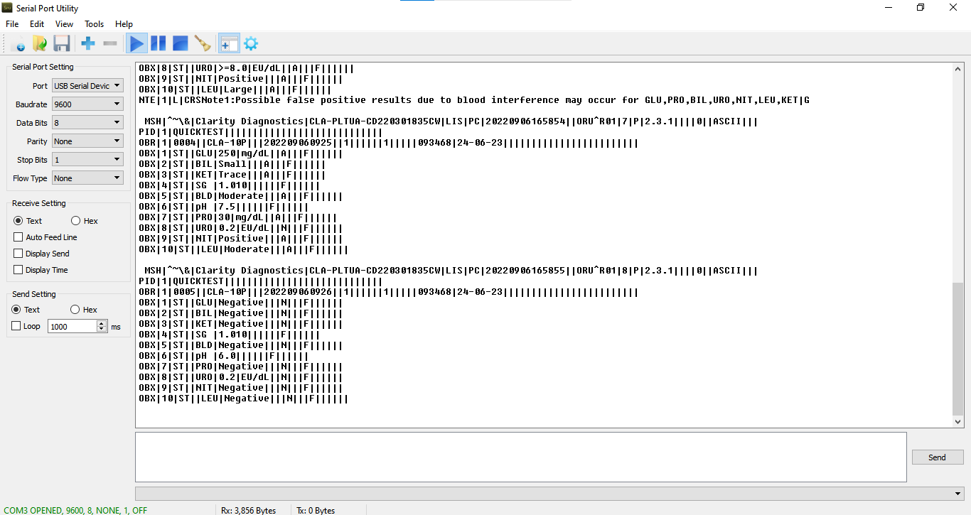

1. Create a text file (on Desktop recommended) – (Right clicking -> New -> Text Document).
2. Go back to the SPU, select all (Ctrl-A) and copy (Ctrl-C) the results and past (Ctrl-V) them onto the text file.
   1. Repeat for each SPU window
3. Go to the QC Documents Software folder and double click to start the software:Graphical user interface, text, application, chat or text message

   Description automatically generated
   1. P.S: A Windows Defender warning may pop up when trying to run the software. Do not worry because it warns you whenever a software is not developed by a registered developer. Hit “More Info” and a “Run” button will show up to bypass this warning.
4. The software should look like:

* 1. The white screen is the UI
  2. Do not worry about the black window (the terminal), but do not close it. It is there when the program runs and will show information helpful for debugging.

1. Hit the “Load File” button on the UI and the following window will show up. Navigate to the saved text file and double click to load it (or hit “Open” after selecting it).

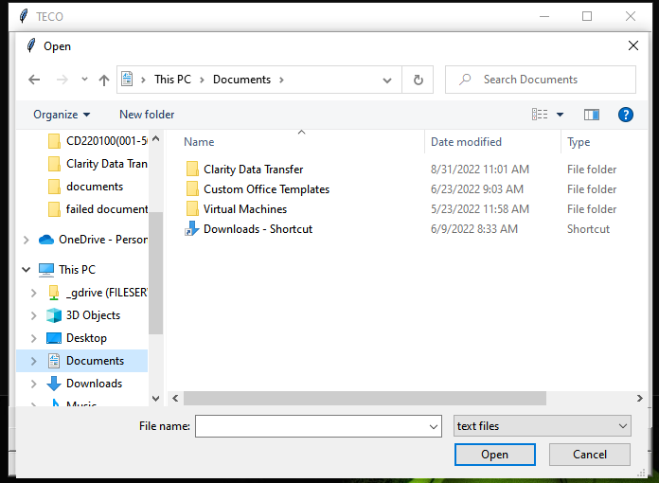

1. After loading the file and entering the tester name, this is what the software will look like:

* 1. Enter the tester name in the format as to appear on the Lab Worksheet (“FirstName LastInitial.”), like show in the screenshot
  2. The results in here cannot be edited. If you see an error, please change it in the text file, save it, then load it into the software again

1. Click “Submit” and the program will generate the COAs and Lab Worksheets from the text file.
   1. The documents will be saved in the “documents” folder and the ones that failed QC will be in the “failed documents” folder.

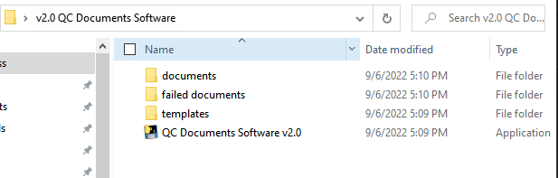

## Warnings and Errors

1. Machine Error:
   1. When the software detects a result that is out of the allowed ranges, a popup like the following will show up:

* 1. The software will still generate the documents, but they will be saved in the “failed documents” folder, and they will have watermarks saying “Failed QC”

1. Code Error:
   1. When a bug in the code happens, a popup like this will show up:

* 1. It is best to contact someone with coding experience to debug the software
  2. P.S: A “list index out of range” error like this one is often caused by incorrect format of the text file